

**SIX WEEKS SUMMER TRAINING REPORT**

On

**Front End Web Development**

Submitted by

**Deepak Kumar**

**11703019**

**B.Tech. – CSE**

Under the guidance of

|  |  |
| --- | --- |
| **Nanda Kishore** | **Shashi Shekhaar** |

**School of Computer Science and Engineering**

**Lovely Professional University, Phagwara**

*( June – July, 2019 )*

**DECLARATION**

I hereby declare that I have completed my six weeks summer training at ____**Board Infinity**_____ from 28**/05/2019** to **20/06/2019** under the guidance of **Nanda Kishore and Shashi Shekhaar**. I have declare that I have worked with full dedication during these six weeks of training and my learning outcomes fulfil the requirements of training for the award of degree of Bachelors of Computer Science and Engineering, Lovely Professional University, Phagwara.

(Signature)

Deepak Kumar

Registration no: 11703019

Date: 20/06/2019

**Acknowledgment**

During the period of my summer training work, I have received generous help from many quarters, which I like to put on record here with deep gratitude and great pleasure.

First and foremost, I am grateful to the Board Infinity, an online learning platform, for making learning such skills easier for students like us. It allowed me to learn according to my time availability and helped me to adjust my timelines by uploading recorded lectures as well as we can attend live lectures everyday. The reviews and comments that I got on my assignments were very generous and helped me to learn more and more. The community on this platform helped me to grow as I was learning this technology.

Secondly, I would like to thanks the Nanda Kishore and Shashi Shekhar for providing their valuable time throughout the courses and making this specialization available for everyone.

My special thanks to Lovely Professional University for giving me a chance to do this summer training as a part of my curriculum and become more aware of the modern technologies. Without this plan of the curriculum, I would probably not have done something like this.

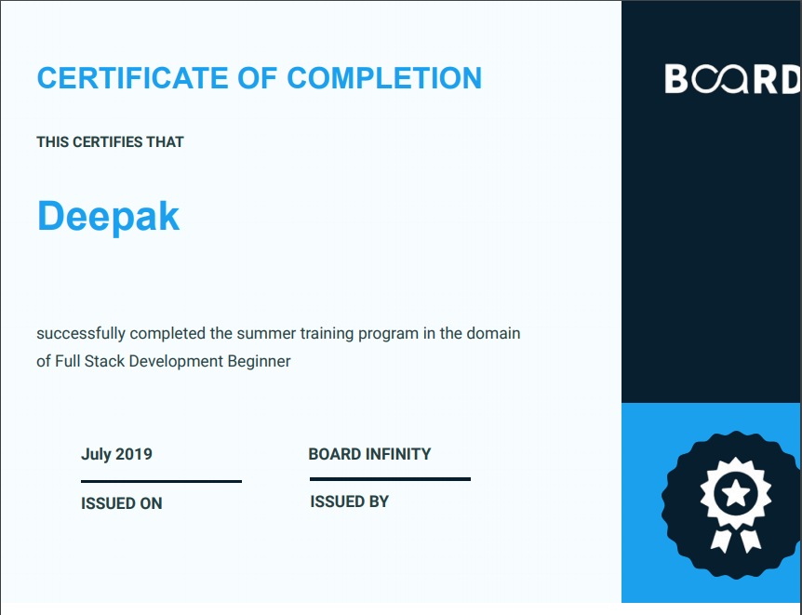

**Table of Contents**

|  |  |  |
| --- | --- | --- |
| Sr. No. | Title | Page No. |
| 1. | Introduction | 1 |
| 2. | Profile of problem | 2 |
| 3. | Existing | 3 |
| 4. | Problem Analysis  1) Product Defination  2) Feasibilty Analysis | 4 |
| 5. | Software requirement analysis | 5-6 |
| 6. | Design or Flowchart | 7 |
| 7. | Testing | 8-10 |
| 8 | Implementation | 11-13 |
| 5. | Gantt Chart | 14 |
| 6 | Project Legacy   1. Technical 2. Managerial | 15 |
| 6 | Bibliography | 16 |

**Introduction**

This project is based on website development for the E-commerce site. As we know that in today’s world online ordering of all the goods are getting popular. So, it’s beneficial for shops in the small cities to get their business online.

Websites are designed to accomplish a specific purpose. Many websites are used for businesses or to make a profit. Websites, which compete in the business world, have many strict guidelines to follow. Effective file management, functional markup codes, and functional navigation tools are some of the properties a good website will have. Shops and malls are known to compete with each other, mainly through advertisement. With an effective website that is up and running, a customer can navigate to the prices they want and know what they are going to order before they even arrive. A website that is designed for a particular shop will give the shop a significant advantage over a shop without a well-maintained website in place.

Creating a website that revolves around a particular shop would be very interesting. Often times the website contains more than just information, it contains very appealing pictures of phones and many other electronic stuffs. Many websites include their products online to attract more customers. In order to place their order online a website designer is required many times. Designing a website in the e-commerce business can be lots of fun, however it will require maintenance. As the product prices and stock values change so will the website be changing at each and every moment. Many shops even allow the customers to place orders online to allow easy access and boost their sales. According to Derek Gehl, the CEO of the Internet Marketing Center, “Instead of trying to please everyone who visits your site by offering a large range of products with minimal detail about each one, if you offer just one product-or one set of related products-you can really focus on one key set of benefits and answer all the possible questions and doubts your visitors might have about your product.”

So, I contacted owner of a small shop which is very popular, to tell them benefits of online business and how companies like Flipkart, Amazon are making a huge profit out of it. I got him convinced to make a website for his shop so that he could expand his business and grow his chain of Shop to other cities.

Currently, I’m building a static website for his shop to show him as a prototype and further after his consent I hope to get it online too.

**Profile Of Problem**

In a developing india online ordering have a great effect in technological life. Everyone is becoming lazy and does not want to move even for their daily needs.All they wanted is to everything with the help of technology.As we can take example of big cities every Shop have their own websites and have registered themselves for online ordering scheme. Many sites such as Flipkart, Amazon made everyone’s life so comfortable that they can have their products within two or three days.This is having a great effect on people as they can get evrything online in their homes easily.

Now in small cities where these services are not being developed.Many people are lacking to use those resources. Also, there are some shops in these cities which are very popular that they need to explore their buisness.People are not able to get online orders as there is no such website of a shop. So in this growing technical world we need to add hands on technology to provide more facilities for people in small cities.

**Existing**

There are lots of existing products in market.In big cities like chandigarh and delhi we have Shops and Malls which have their own websites.Also there are some existing products such as Flipkart and Amazon which provide facility of online ordering of various Shops.Myntra company has had a [tumultuous few years](https://techstory.in/zomato-success-story/), but since 2017 things are looking up. With massively successful business tie-ups like Flipkart Plus and online Products delivery, it has established a heavy consumer base, especially in India. The company has had its shares of ups and downs but has always emerged to survive.

But in my city there is no such existing product in the market.No shop provide online products ordering .So, our product will be one of the existing products at small scale.

**Problem Analysis**

**Product Defination:**

This website basicaly is all about online ordering as well as a official website of a shop. Nadda Sales is a very popular shop in my city Ghumarwin. They have four stores in Ghumarwin. This website contain home page where a user can go to menu or he can choose what he want the products are further cateogarized into sub cateogaries such as Electronics Food etc and can go for online order. In home page we have photos.In the Home Page we have the some latest offers and we have also a login page that contains the information about the user if the information is correct then he can enter into the Home page From a website user can order as well as can know about the products.

**Feasibility Analysis:**

An analysis and evaluation of a proposed project to determine if it

1. **is technically feasible** :

Website would be technically feasible as it provides online order on any device.

1. **is feasible within the estimated cost :**

Product will be cost effective.

1. **and will be profitable :**

It will be profitable as it will increase market demand and will give more and more profit to owners.

**Software Requirement Analysis**

# Specific Requirements

## Functional Requirements

The Functional Requirements of Website are :

**Functional requirement 1:**

* **Description: New User**
* **Input:** Click on New User button .
* **Processing:** Opening Registration webpage.
* **Output:** A new page of registration will open in same tab.

**Functional requirement 2:**

* **Description:** Sign in to personal accounts.
* **Input:** User Id and passwords details.
* **Processing:** Matches related to the entered Id and Password.

**Output:** Login with personal account opened will be shown.

**Functional requirement 3:**

* **Description:** If user have not signed in then details will be shown in guest mode.

**Functional requirement 4:**

* **Description:** Checking products of the shop.
* **Input:** Click on the product cateogaries button on homepage.
* **Processing:** Load the page.

**Output:** New products page will be loaded in the same tab..

# External Interface Requirements

## User Interfaces

The customer user interface and design should be intuitive and user-friendly, such that 99.9% of all new users are able to navigate through different sections and different features easily.

## Hardware Interfaces

The hardware should have following specifications:

* Ability to recieve order from user.
* Ability to take input from user.
* Ability to search a particular product.

# 3 Other Nonfunctional Requirements

## 3.1 Performance Requirements

* It should work fine with low network speed.
* This must be responsive in less time.

## 3.2 Availability

* Updates regarding delivery should be given time to time.
* User should be able to access information of any item at any time.

## 3.3 Recoverability

The system should have proper team for backup when ever required during high use of website(crashing of website).

## 3.4 Maintainability

The website must be maintained regularly and time to time updates should be there to enhance facilities.

**Design :**

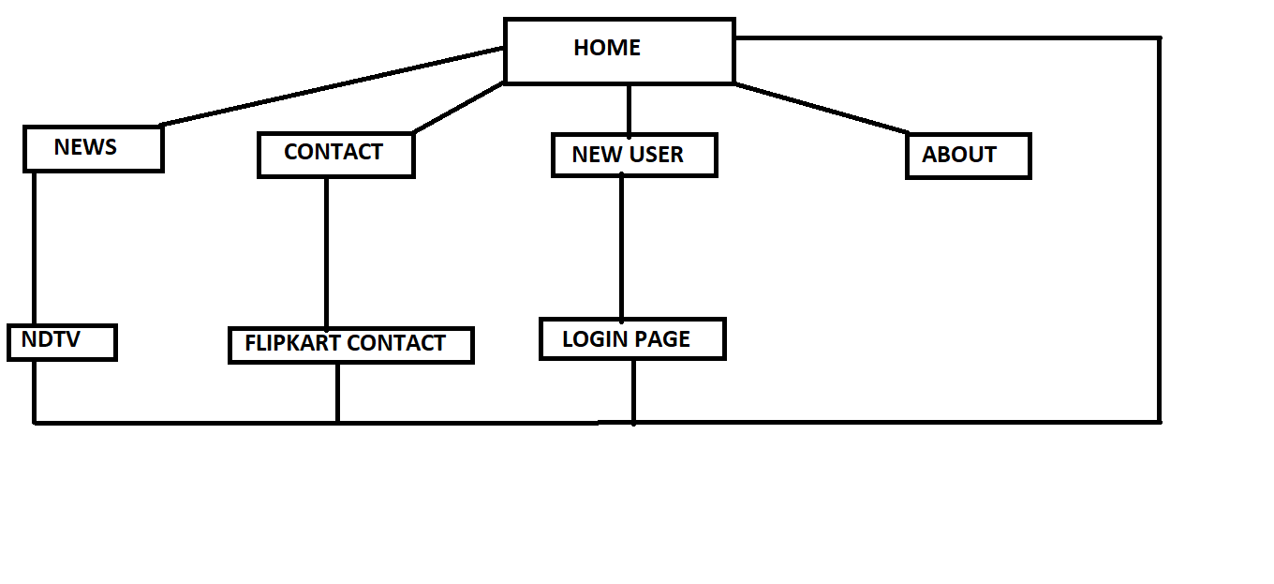

**Testing :**

A **test case** is a specification of the inputs, execution conditions, **testing** procedure, and expected results that define a single **test** to be executed to achieve a particular software **testing** objective, such as to exercise a particular program path or to verify compliance with a specific requirement.

1. **Connection of Electronics button:** If we click electronics button on home page, whether electronics page opens or not.

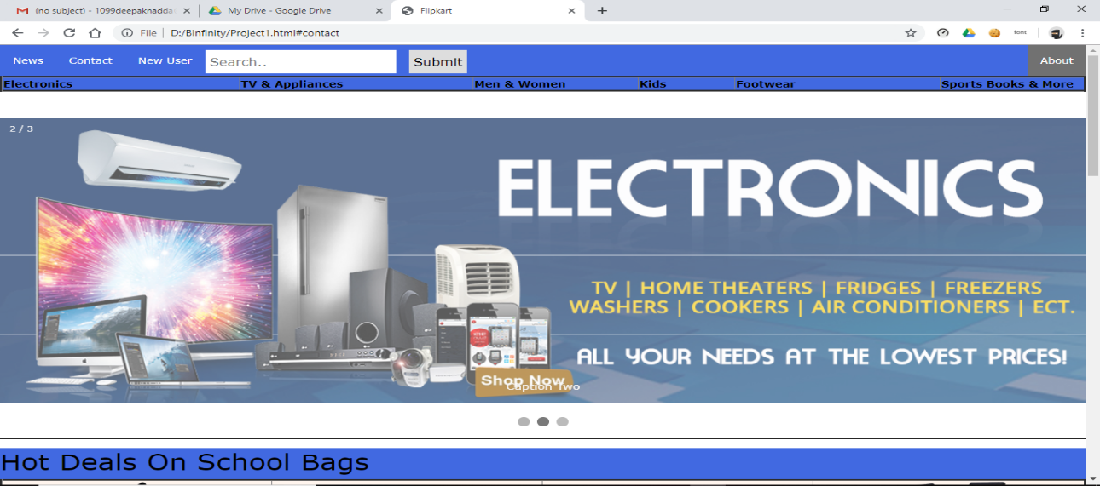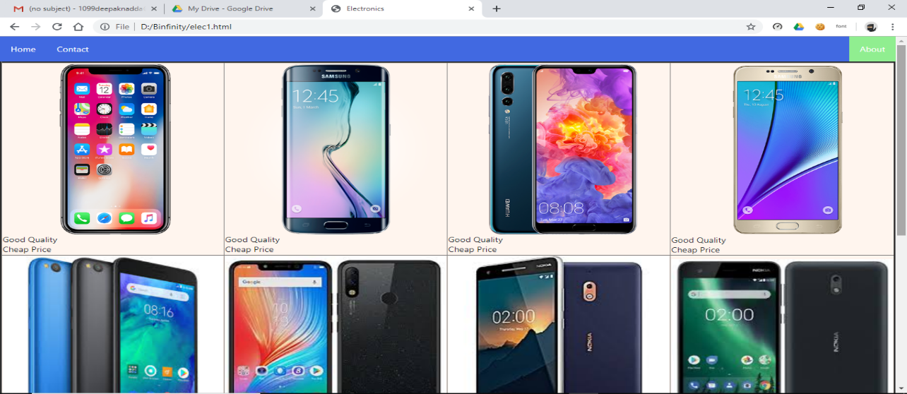

Result: Worked fine.

1. **Connection of every button:** If we click on any button whether it open the webpage linked to it or not.

Result: Successfully opened.

1. **Slideshow images:** Slideshow whether changing image or not after few seconds (automatically).

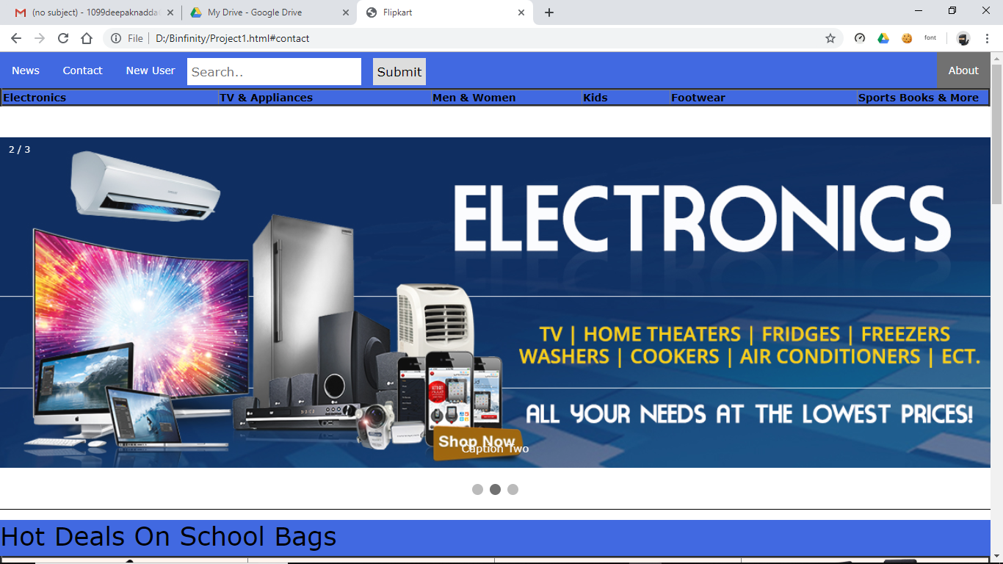

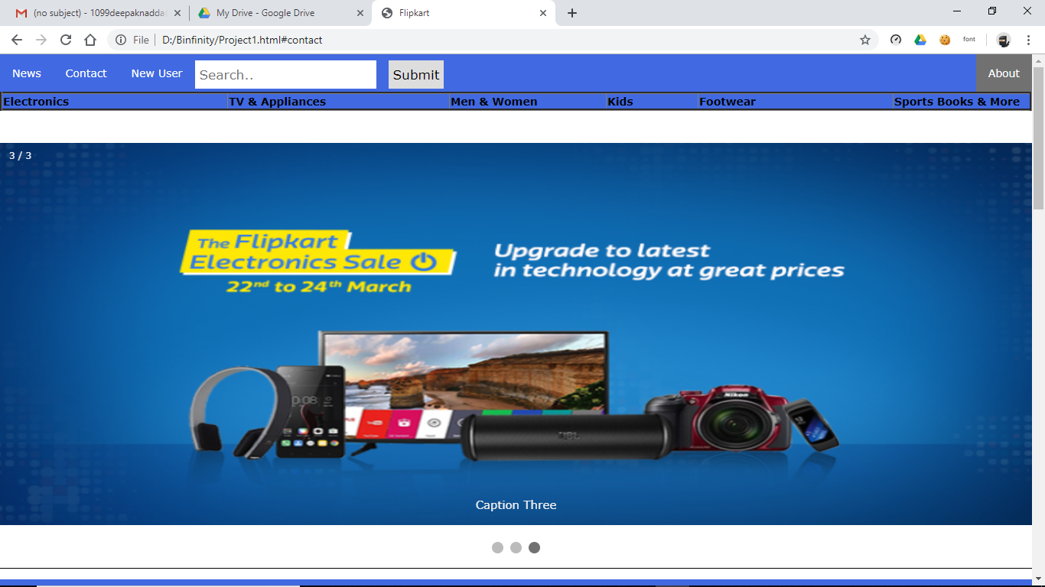

1. **On-hover Javascript:**  Whether javascript is working fine or not.

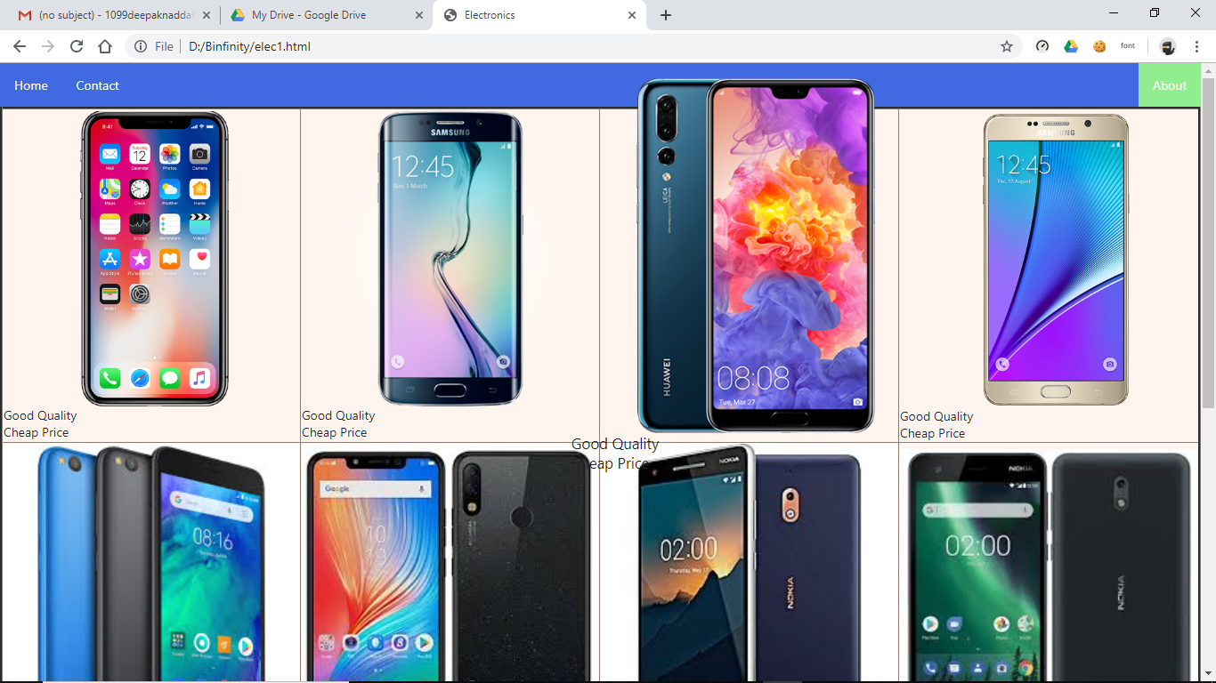

Result : Worked fine, As whenever we are mouse over on the image it transforms in to 1.2 scale.

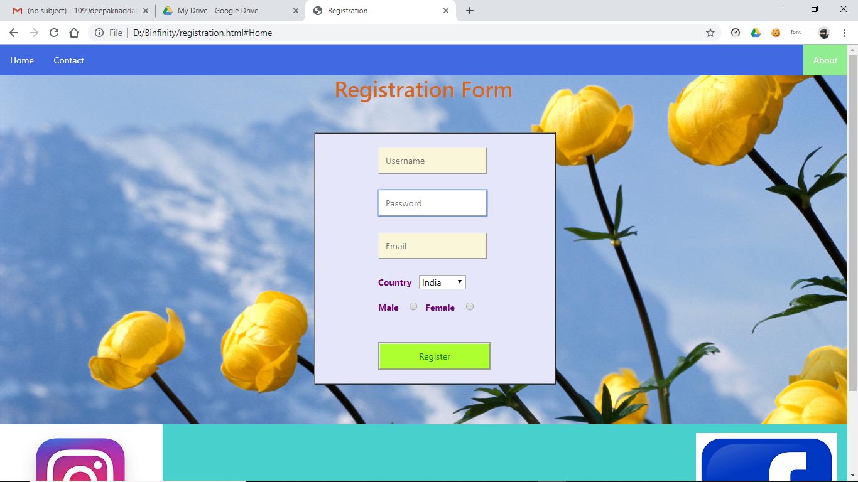

Result : Worked fine, As whenever we are mouse over on the particular section of menu, let’s say in password it changes its background color to white and again changes to original when mouse out .

**Implementation:**

**Here are some screenshot of website.**

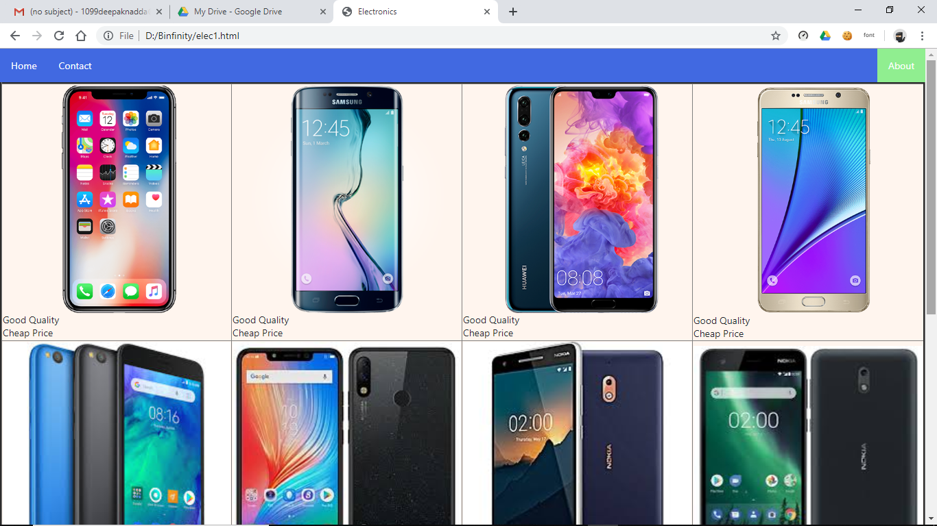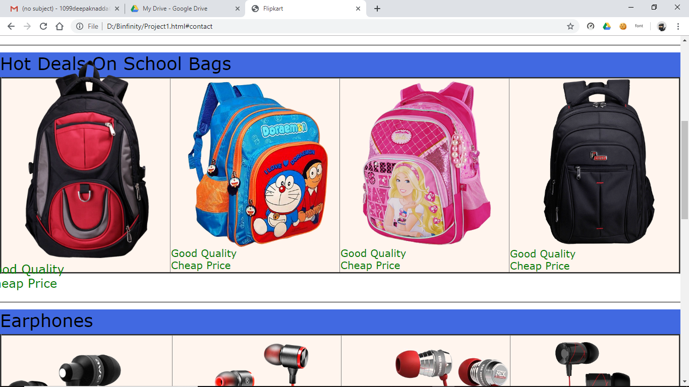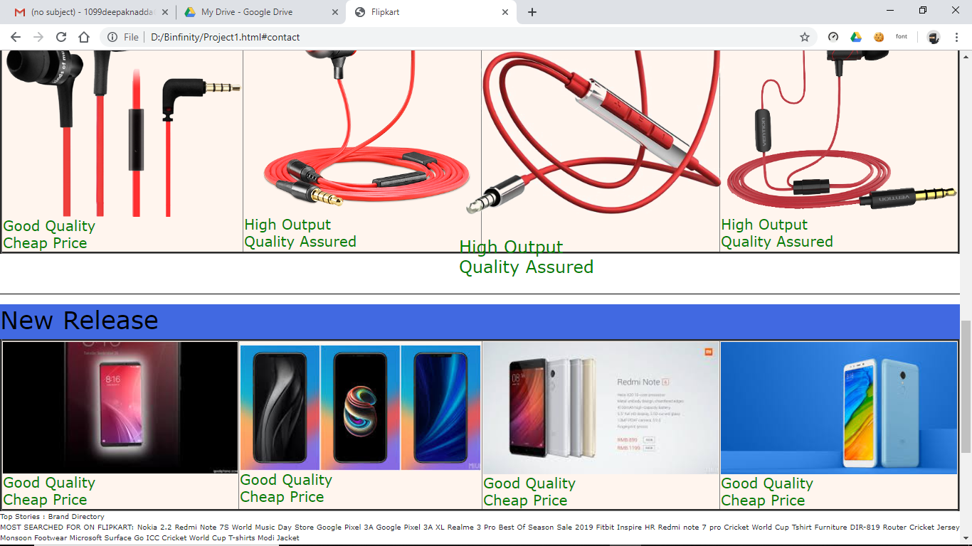

**GANTT CHART**

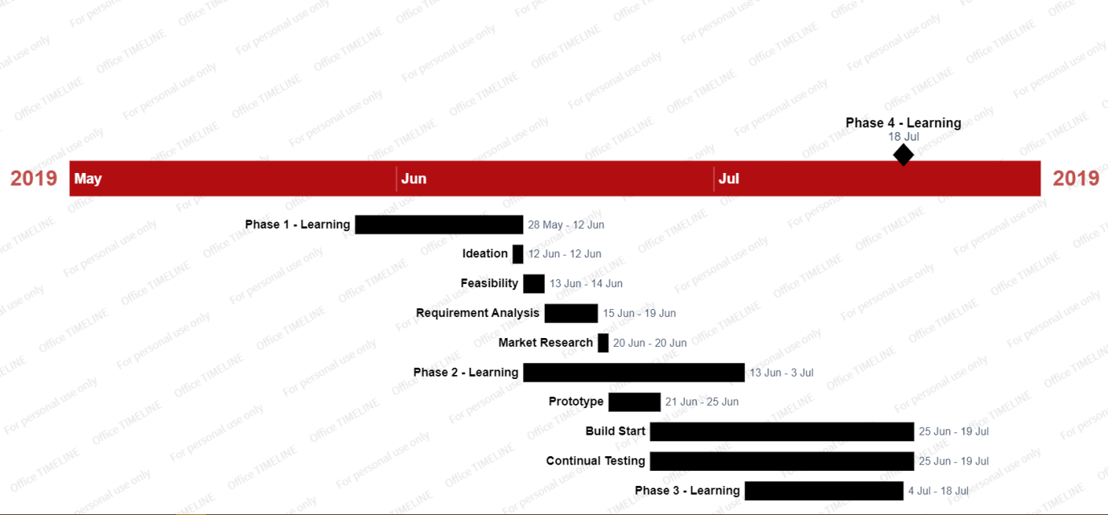

**Project Legacy:**

1. **Technical:**

I learnt how to combine technical skills to solve current problems.In this project basically I uses html, css, javascript to make a static website.

HTML: code used to structure a web page and its content.

CSS: describes the style of an HTML document. **CSS** describes how HTML elements should be displayed

JAVASCRIPT: high level programming language used to bring changes in html and css by adding events etc.

1. **Managerial Lessons:**
2. Time Management
3. Decision Making Ability
4. Don’t search for a project idea.Search for a problem to solve
5. Fine a solution to problems around you.
6. Mentorship matters more than the technology stack.
7. Find real users to test and use your real-world project.

**Bibliography**

* Board Infinity (Full Stack Course)
* Guide to JavaScript by Mozilla Developers

<<https://developer.mozilla.org/en-US/docs/Web/JavaScript/Guide/Introduction>>

* W3Schools

www.w3schools.com

* Zomato Story

<www.techstory.in>

<www.thesitewizard.com>